FREQUENCY POLYGONS
Pearson Edexcel - Tuesday 11 June 2019 - Paper 3 (Calculator) Foundation Tier

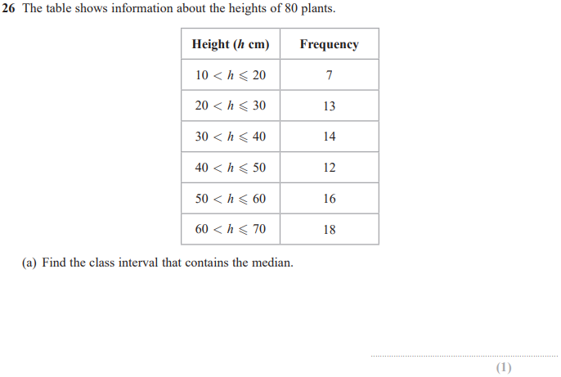
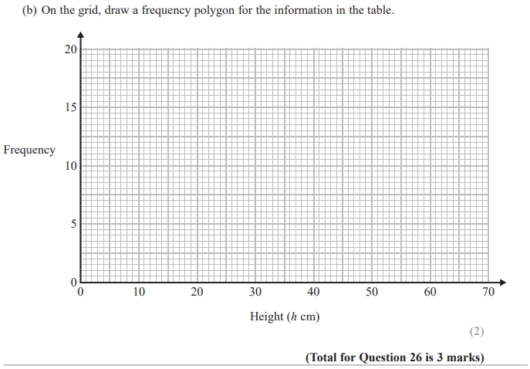

Pearson Edexcel - Wednesday 8 November 2017 - Paper 3 (Calculator) Foundation Tier

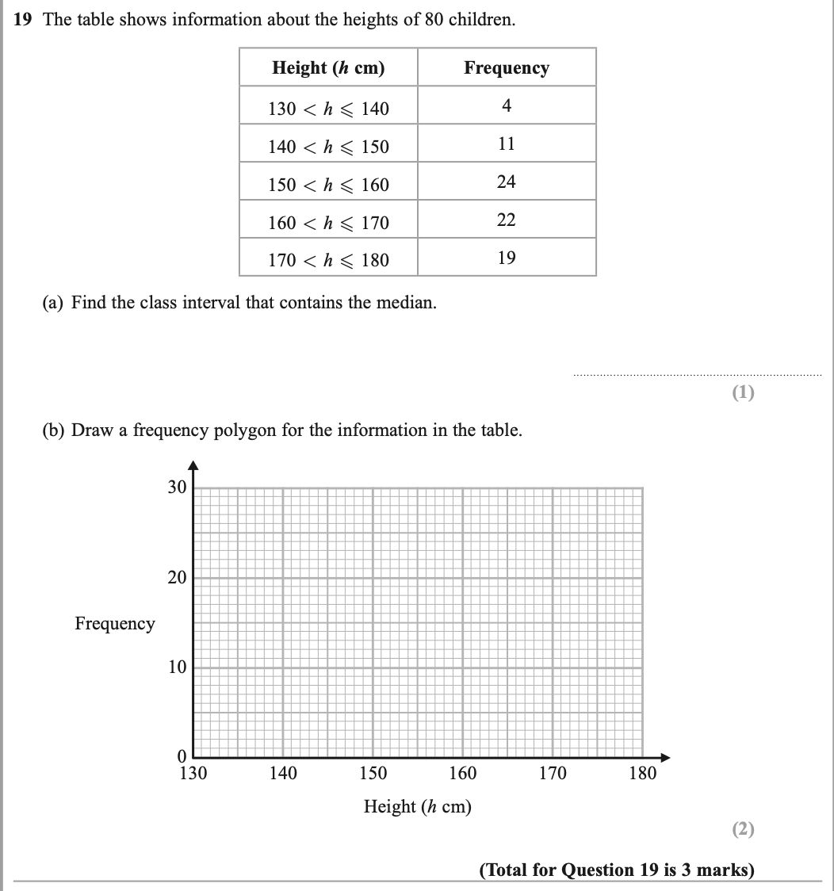

Pearson Edexcel – Specimen 1 - Paper 2 (Calculator) Foundation Tier

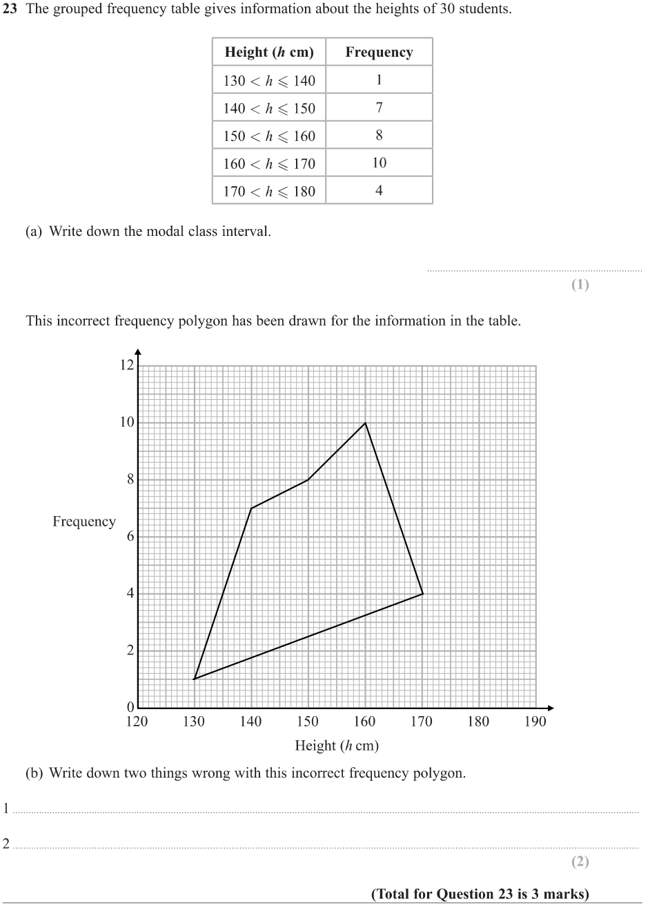
OCR Sample Question Paper 3 – Morning/Afternoon (Calculator) Foundation Tier

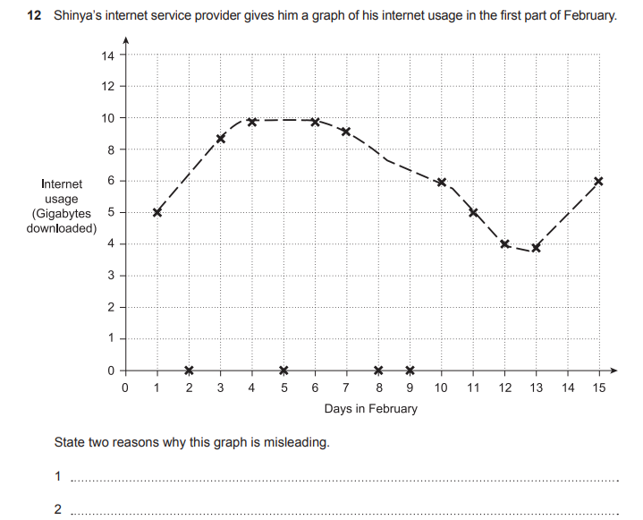

AQA Thursday 4 June 2020 – Morning (Calculator) Foundation Tier

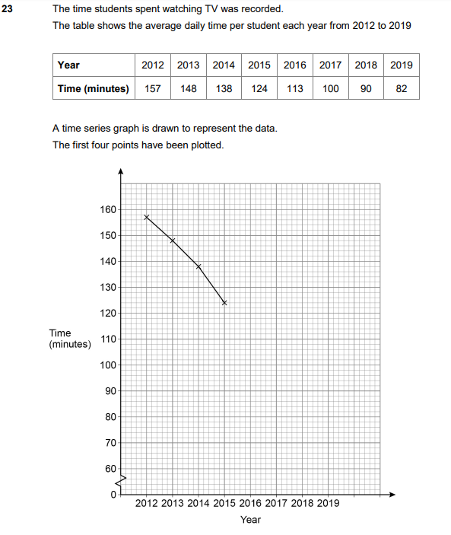

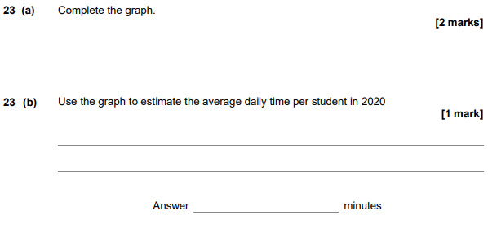

AQA Monday 12 November 2018 – Morning (Calculator) Foundation Tier

